Group Webpage Activity

Objective
Create a group webpage with your final project team using HTML, CSS, and JavaScript to showcase your team’s identity as computer scientists. This page should include your team’s background, unique character, and values.
You may use the provided template as a starting point or create your own structure from scratch.
Group Bio Template
Read the whole document carefully before you begin working. Each member is expected to add at least one commit to the shared repository.

Resources
- HTML/CSS Tutorials
  - HTML
  - CSS
  - JS
- JavaScript Basics

Getting Started

- Create a new Pycharm project with a virtual environment
- Write the following line in the terminal
  - git clone https://github.com/sandrawiktor/group_bio_template
- Right click on the index.html file, navigate to Open In >> Browser >> Built-In Preview as shown below.
- 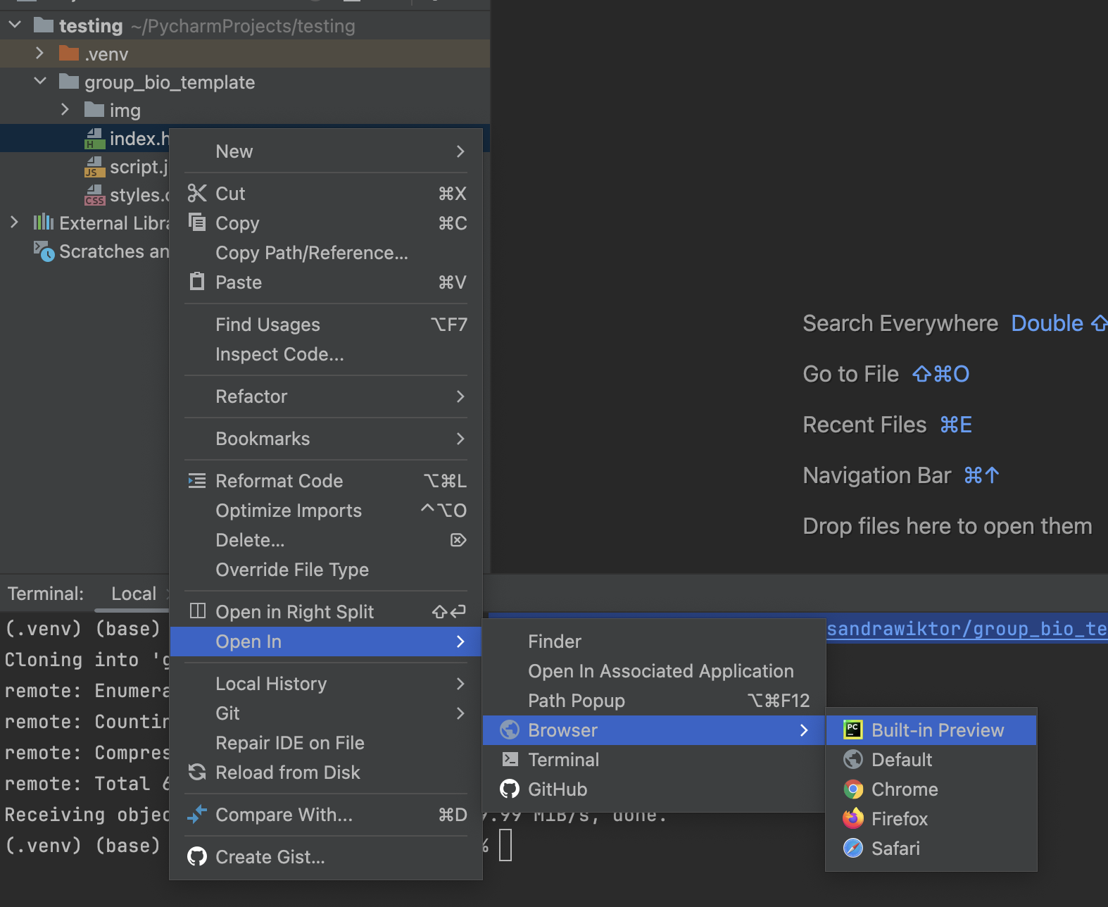
  - You can also open it in any browser.
- 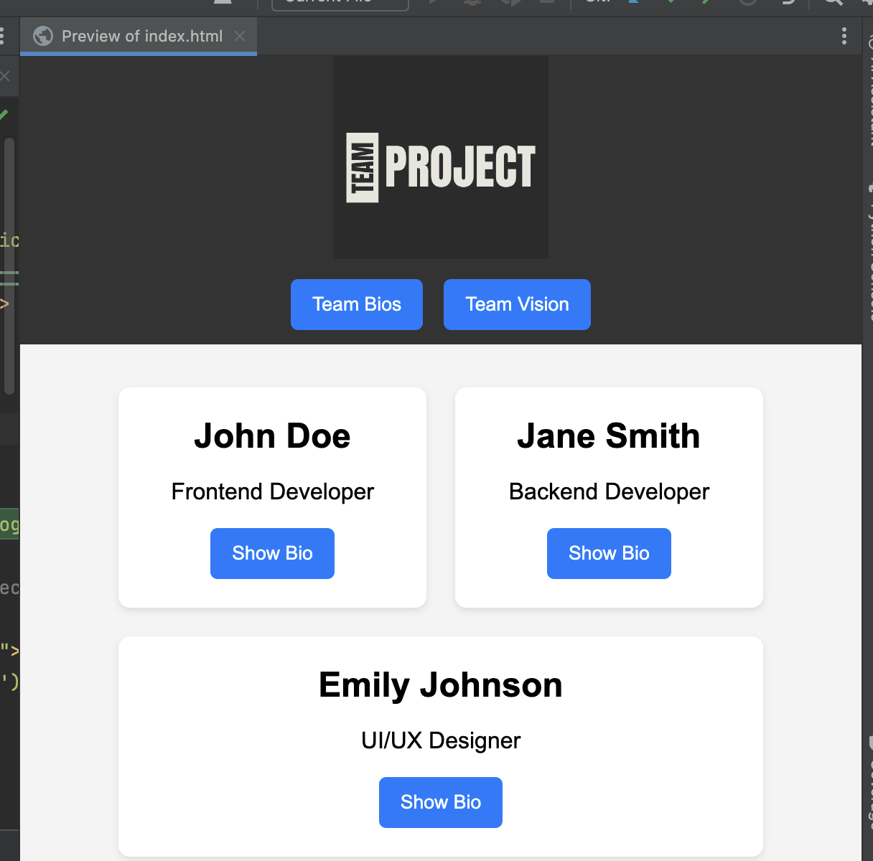
  - Try out the template and get familiar with its functionality.
- One member of your team should create a GitHub remote repository and push the base version of your code. Then, each member should clone the repository to their local machine. We recommend you all work on separate branches.
- Go through the code and get familiar with each component. Once you feel comfortable with the template, you can start modifying it! Make sure to go through the resources on the Canvas page and this guide.

Requirements

1. Modified Bios Page
- Individual Bios: Each team member’s bio should include:
  - A photo or avatar.
  - A “moodboard” that showcases inspirations in computer science (e.g., favorite tools, concepts, or influential figures). The moodboard can include:
    - Images (e.g., symbols, memes).
    - Links (e.g., to GitHub, favorite resources).
- Creativity: Make each bio visually unique, reflecting each member’s personal style.

2. Team Vision/Mission Statement
- Write a short mission statement to describe:
  - Your team’s identity—values, goals, or strengths as computer scientists.
  - Team Rules: List agreed-upon rules to support teamwork and respect.

3. CSS Styling
- Apply distinct colors and fonts that represent your team’s identity.
- Use varied styles for headings, bios, and the mission statement to create visual interest.

4. Team Logo
- Include your Team Name
- Design a logo that replaces the template logo, using colors or symbols that represent your team.
- Suggested Tool: Canva Logo Maker

Additional Tips
- Use CSS animations or hover effects to add flair.
- Keep the color scheme and font choices cohesive.
- Comment in your CSS to make future edits easier.
- Consider assigning roles (e.g., designer, developer, content writer) to balance the workload.

Submission Requirements
- Each team member should have at least one commit in the GitHub repository.
- Include the name of each team member that contributed to the activity.

